

Addis Ababa Institute of Technology

Center of Information Technology and Scientific Computing

*Database Administration*

*HR Schema*

Prepared by: - Kalab Amare

ID: - ATR/0078/09

**Oracle HR Schema**

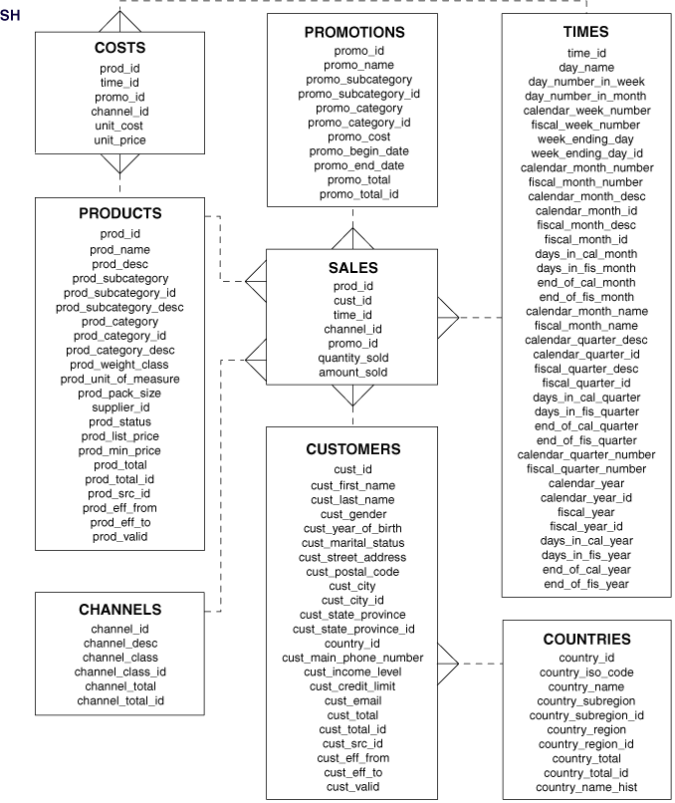

**Description Of Class Diagram**

The costs table has the following attributes:

* Columns: prod_id, time_id, promo_id, channel_id, unit_cost, and unit_price
* Relationships:
  + Column prod_id relates one or more rows of the table costs to one row of the table products with the corresponding value of prod_id.
  + Column time_id relates one or more rows of the table costs to one row of the table times with the corresponding value of time_id.

The products table has the following attributes:

* Columns: prod_id (primary key), prod_name, prod_desc, prod_subcategory, prod_subcategory_id, prod_subcategory_desc, prod_category, prod_category_id, prod_category_desc, prod_weight_class, prod_unit_of_measure, prod_pack_size, supplier_id, prod_status, prod_list_price, prod_min_price, prod_total, prod_total_id, prod_src_id, prod_eff_from, prod_eff_to, and prod_valid
* Relationships:
  + Column prod_id relates rows of the table products to one or more rows of the table sales with the corresponding value of prod_id.
  + Column prod_id relates rows of the table products to one or more rows of the table costs with the corresponding value of prod_id.

The promotions table has the following attributes:

* Columns: promo_id (primary key), promo_name, promo_subcategory, promo_subcategory_id, promo_category, promo_category_id, promo_cost, promo_begin_date, promo_end_date, promo_total and promo_total_id
* Relationships:
  + Column promo_id relates rows of the table promotions to one or more rows of the table sales with the corresponding value of promo_id.

The sales table has the following attributes:

* Columns: prod_id, cust_id, time_id, channel_id, promo_id, quantity_sold, and amount_sold
* Relationships:
  + Column prod_id relates one or more rows of the table sales to a row of the table products with the corresponding value of prod_id.
  + Column promo_id relates one or more rows of the table sales to a row of the table promotions with the corresponding value of promo_id.
  + Column channel_id relates one or more rows of the table sales to a row of the table channels with the corresponding value of channel_id.
  + Column cust_id relates one or more rows of the table sales to a row of the table customers with the corresponding value of cust_id.
  + Column times_id relates one or more rows of the table sales to a row of the table times with the corresponding value of times_id.

The channels table has the following attributes:

* Columns: channel_id (primary key), channel_desc, channel_class, channel_class_id, channel_total, and channel_total_id
* Relationships:
  + Column channel_id relates rows of the table channels to one or more rows of the table sales with the corresponding value of channel_id.

The customers table has the following attributes:

* Columns: cust_id (primary key), cust_first_name, cust_last_name, cust_gender, cust_year_of_birth, cust_marital_status, cust_street_address, cust_postal_code, cust_city, cust_city_id, cust_state_province, cust_state_provice_id, country_id, cust_main_phone_number, cust_income_level, cust_credit_limit, cust_email, cust_total, cust_total_id, cust_src_id, cust_eff_from, cust_eff_to, and cust_valid
* Relationships:
  + Column cust_id relates rows of the table customers to one or more rows of the table sales with the corresponding value of customer_id.
  + Column country_id relates one or more rows of the table customers to one row of the table countries with the corresponding value of country_id

The times table has the following attributes:

* Columns: time_id (primary key), day_name, day_number_in_week, day_number_in_month, calendar_week_number, fiscal_week_number, week_ending_day, week_ending_day_id, calendar_month_number, fiscal_month_number, calendar_month_desc, calendar_month_id, fiscal_month_desc, fiscal_month_id, days_in_cal_month, days_in_fis_month, end_of_cal_month, end_of_fis_month, calendar_month_name, fiscal_month_name, calendar_quarter_desc, calendar_quarter_id, fiscal_quarter_desc, fiscal_quarter_id, days_in_cal_quarter, days_in_fis_quarter, end_of_cal_quarter, end_of_fis_quarter, calendar_quarter_number, fiscal_quarter_number, calendar_year, calendar_year_id, fiscal_year, fiscal_year_id, days_in_cal_year, days_in_fis_year, end_of_cal_year, and end_of_fis_year
* Relationships:
  + Column time_id relates rows of the table times to one or more rows of the table sales with the corresponding value of time_id.

The countries table has the following attributes:

* Columns: country_id (primary key), country_iso_code, country_name, country_subregion, country_subregion_id, country_region, country_region_id, country_total, country_total_id, country_name_hist
* Relationships:
  + Column country_id relates rows of the table countries to one or more rows of the table customers with the corresponding value of country_id.